**SIL Presentation**

**Batch 4 – Group 1**

**Submitted by:**

Centeno, Wendell

Hernaez, Henessy

Jorda, Daff

Ramos, John Adam

Sevilla, Clarisse Joy

**About Zack Gaming:**

This event brings together senior executives from the Philippines and worldwide to offer unmatched insights into the dynamic market. Zack Gaming is intended for individuals from administrators, affiliates, sports clubs, regulatory agencies, and other key industry stakeholders. Non-endemic brands, marketing service providers, digital solution providers, and financial service providers are also sincerely invited, as their contributions are essential to the expansion and prosperity of the sector.

**Target Audience:**

This website caters to a sophisticated audience, honing in on the Philippines' senior executive betting and gaming events. Tailored for top-tier industry professionals, it is a specialized platform exclusively designed for senior executives immersed in the intricacies of betting and gaming in the Philippines. Dive into a space where the latest trends, regulatory insights, and executive-level discussions converge to provide unparalleled value for senior professionals in the industry.

**Logo of the Website:**

**Font:**

Montserrat / Monstserrat Black / Raleway

**Color:**

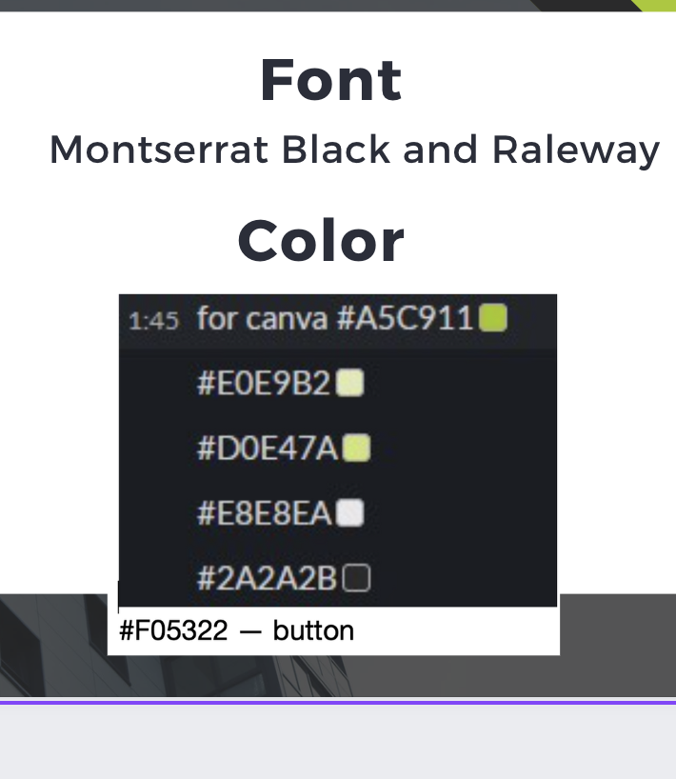

**Header:**

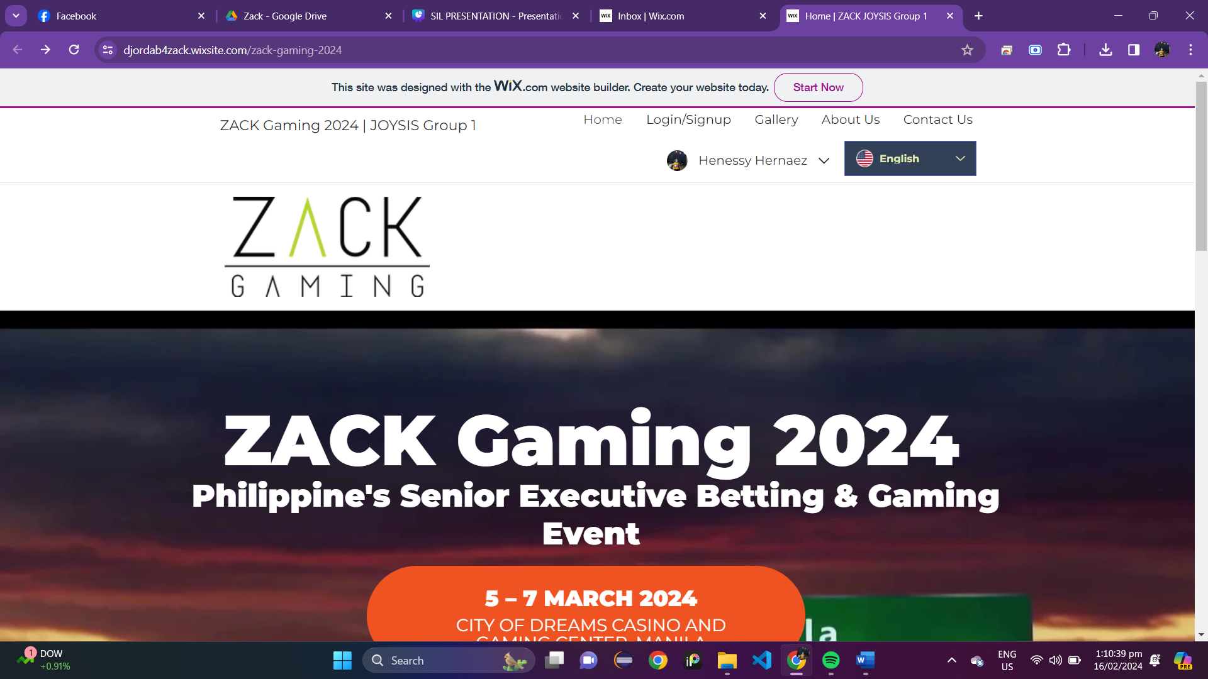

**Footer:**



**Log in:**

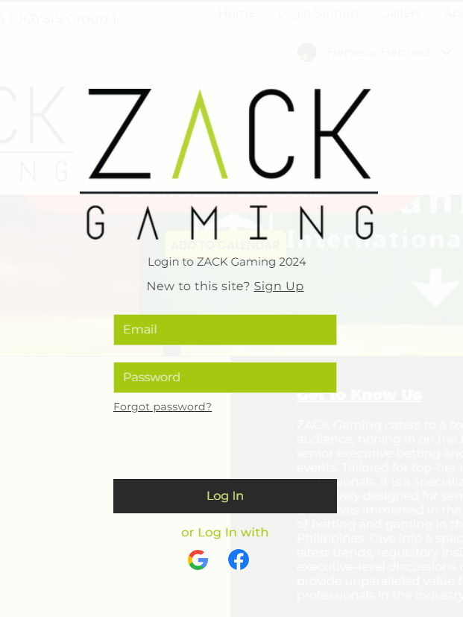

**Sign up:**

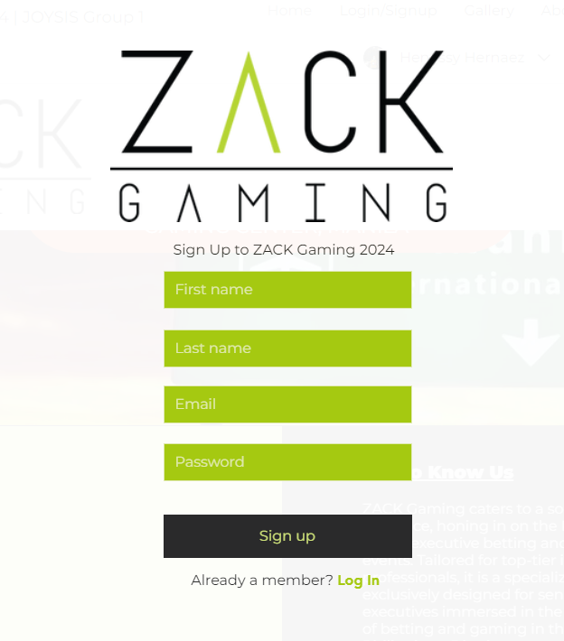

**Sign-up Confirmation:**

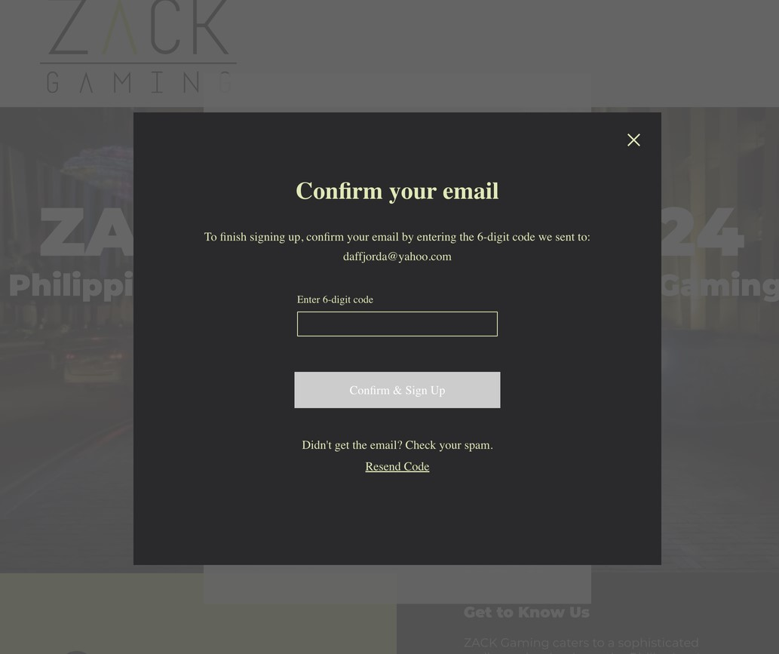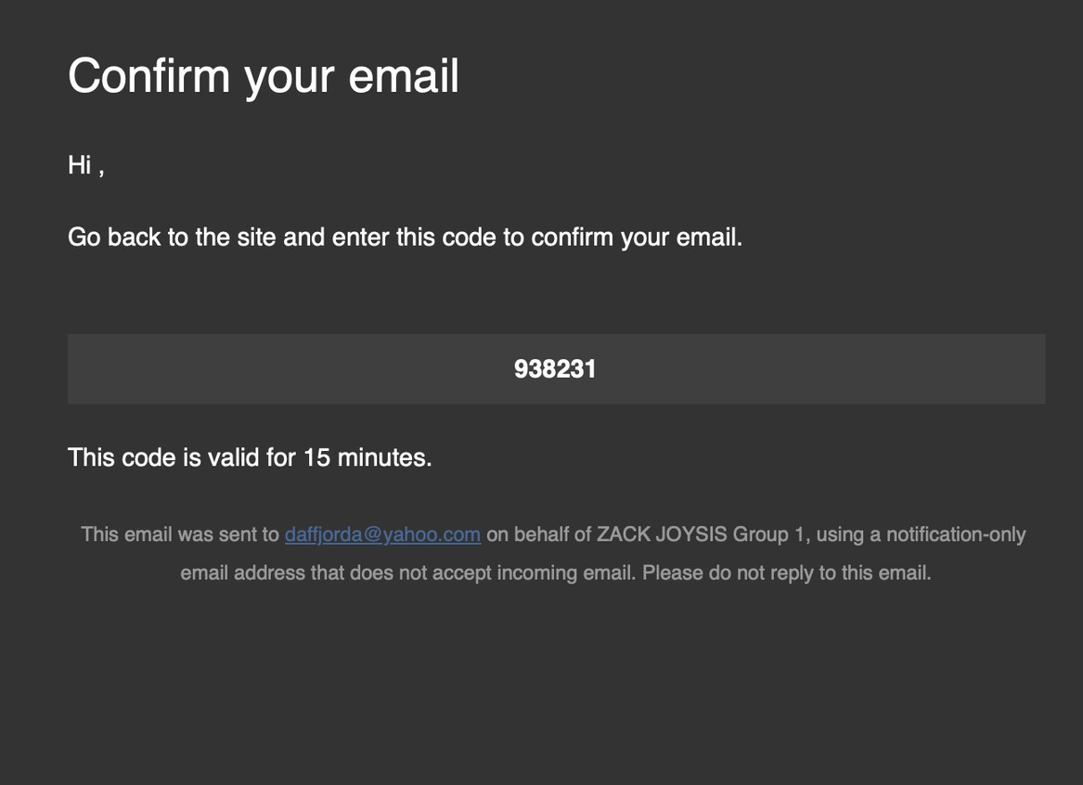



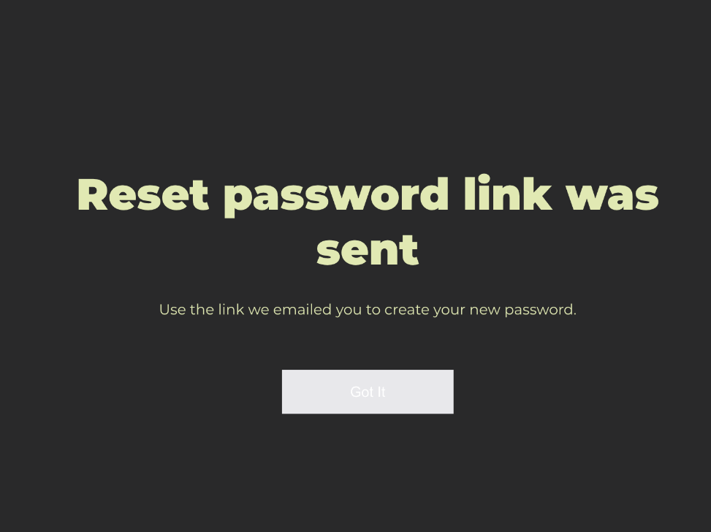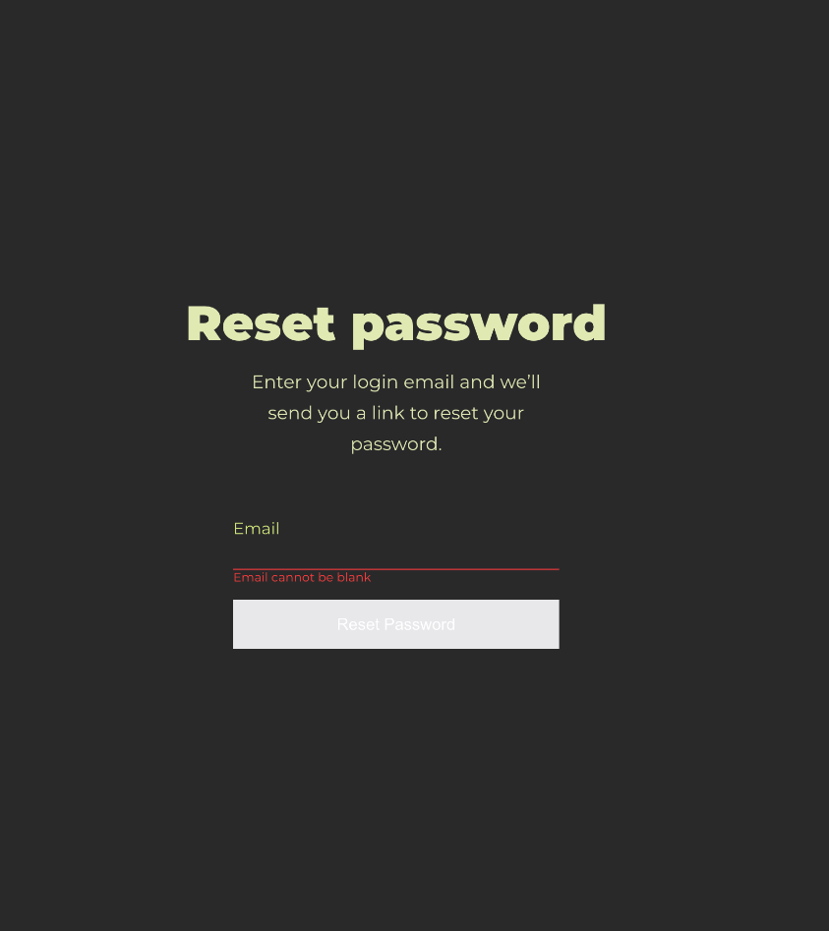**Forgot Password:**

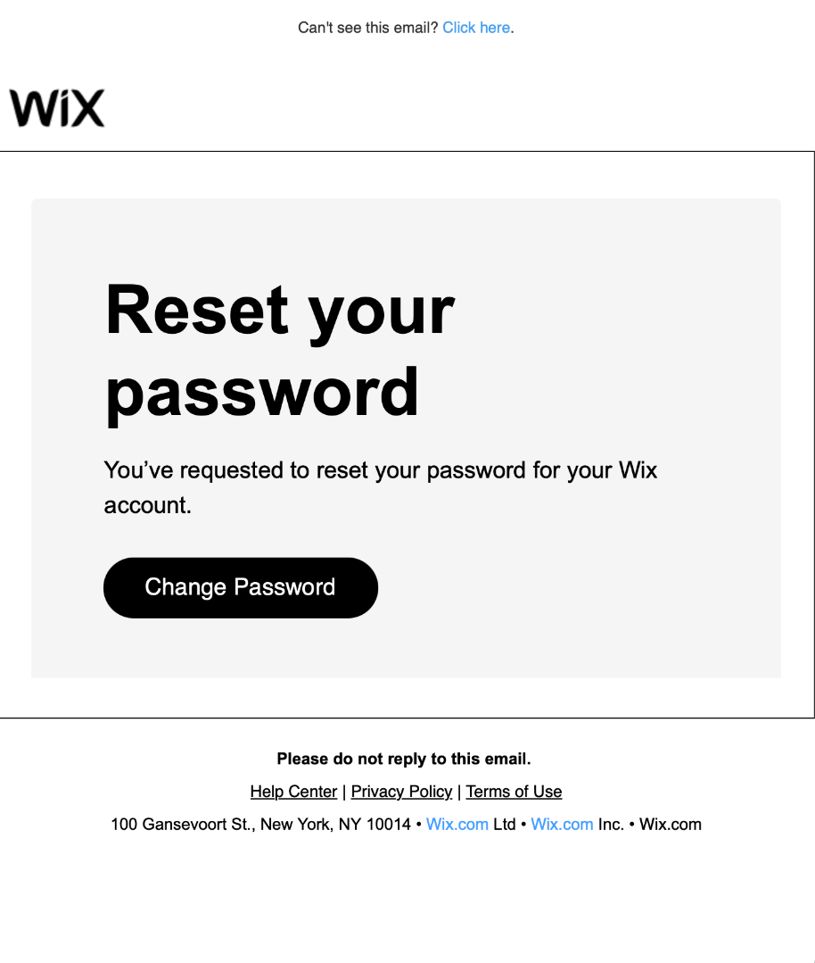

**Log in Drop-down Menu:**

**Homepage:**



**Add to Calendar:**





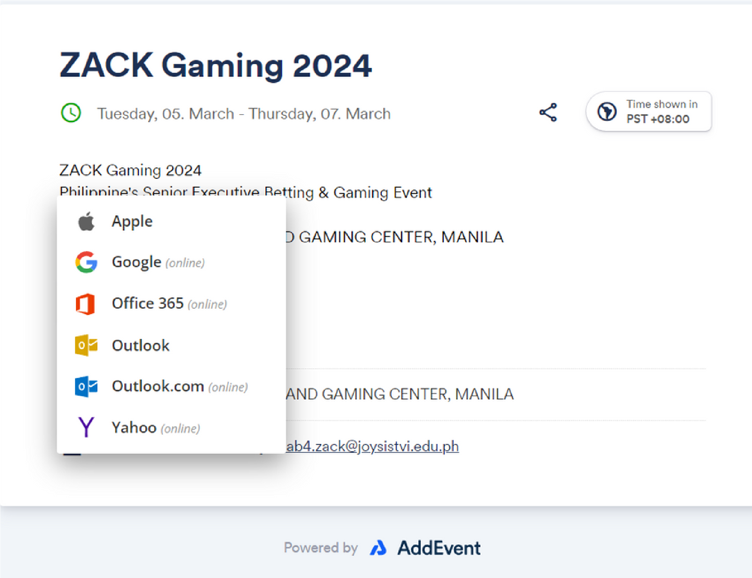**Add event:**

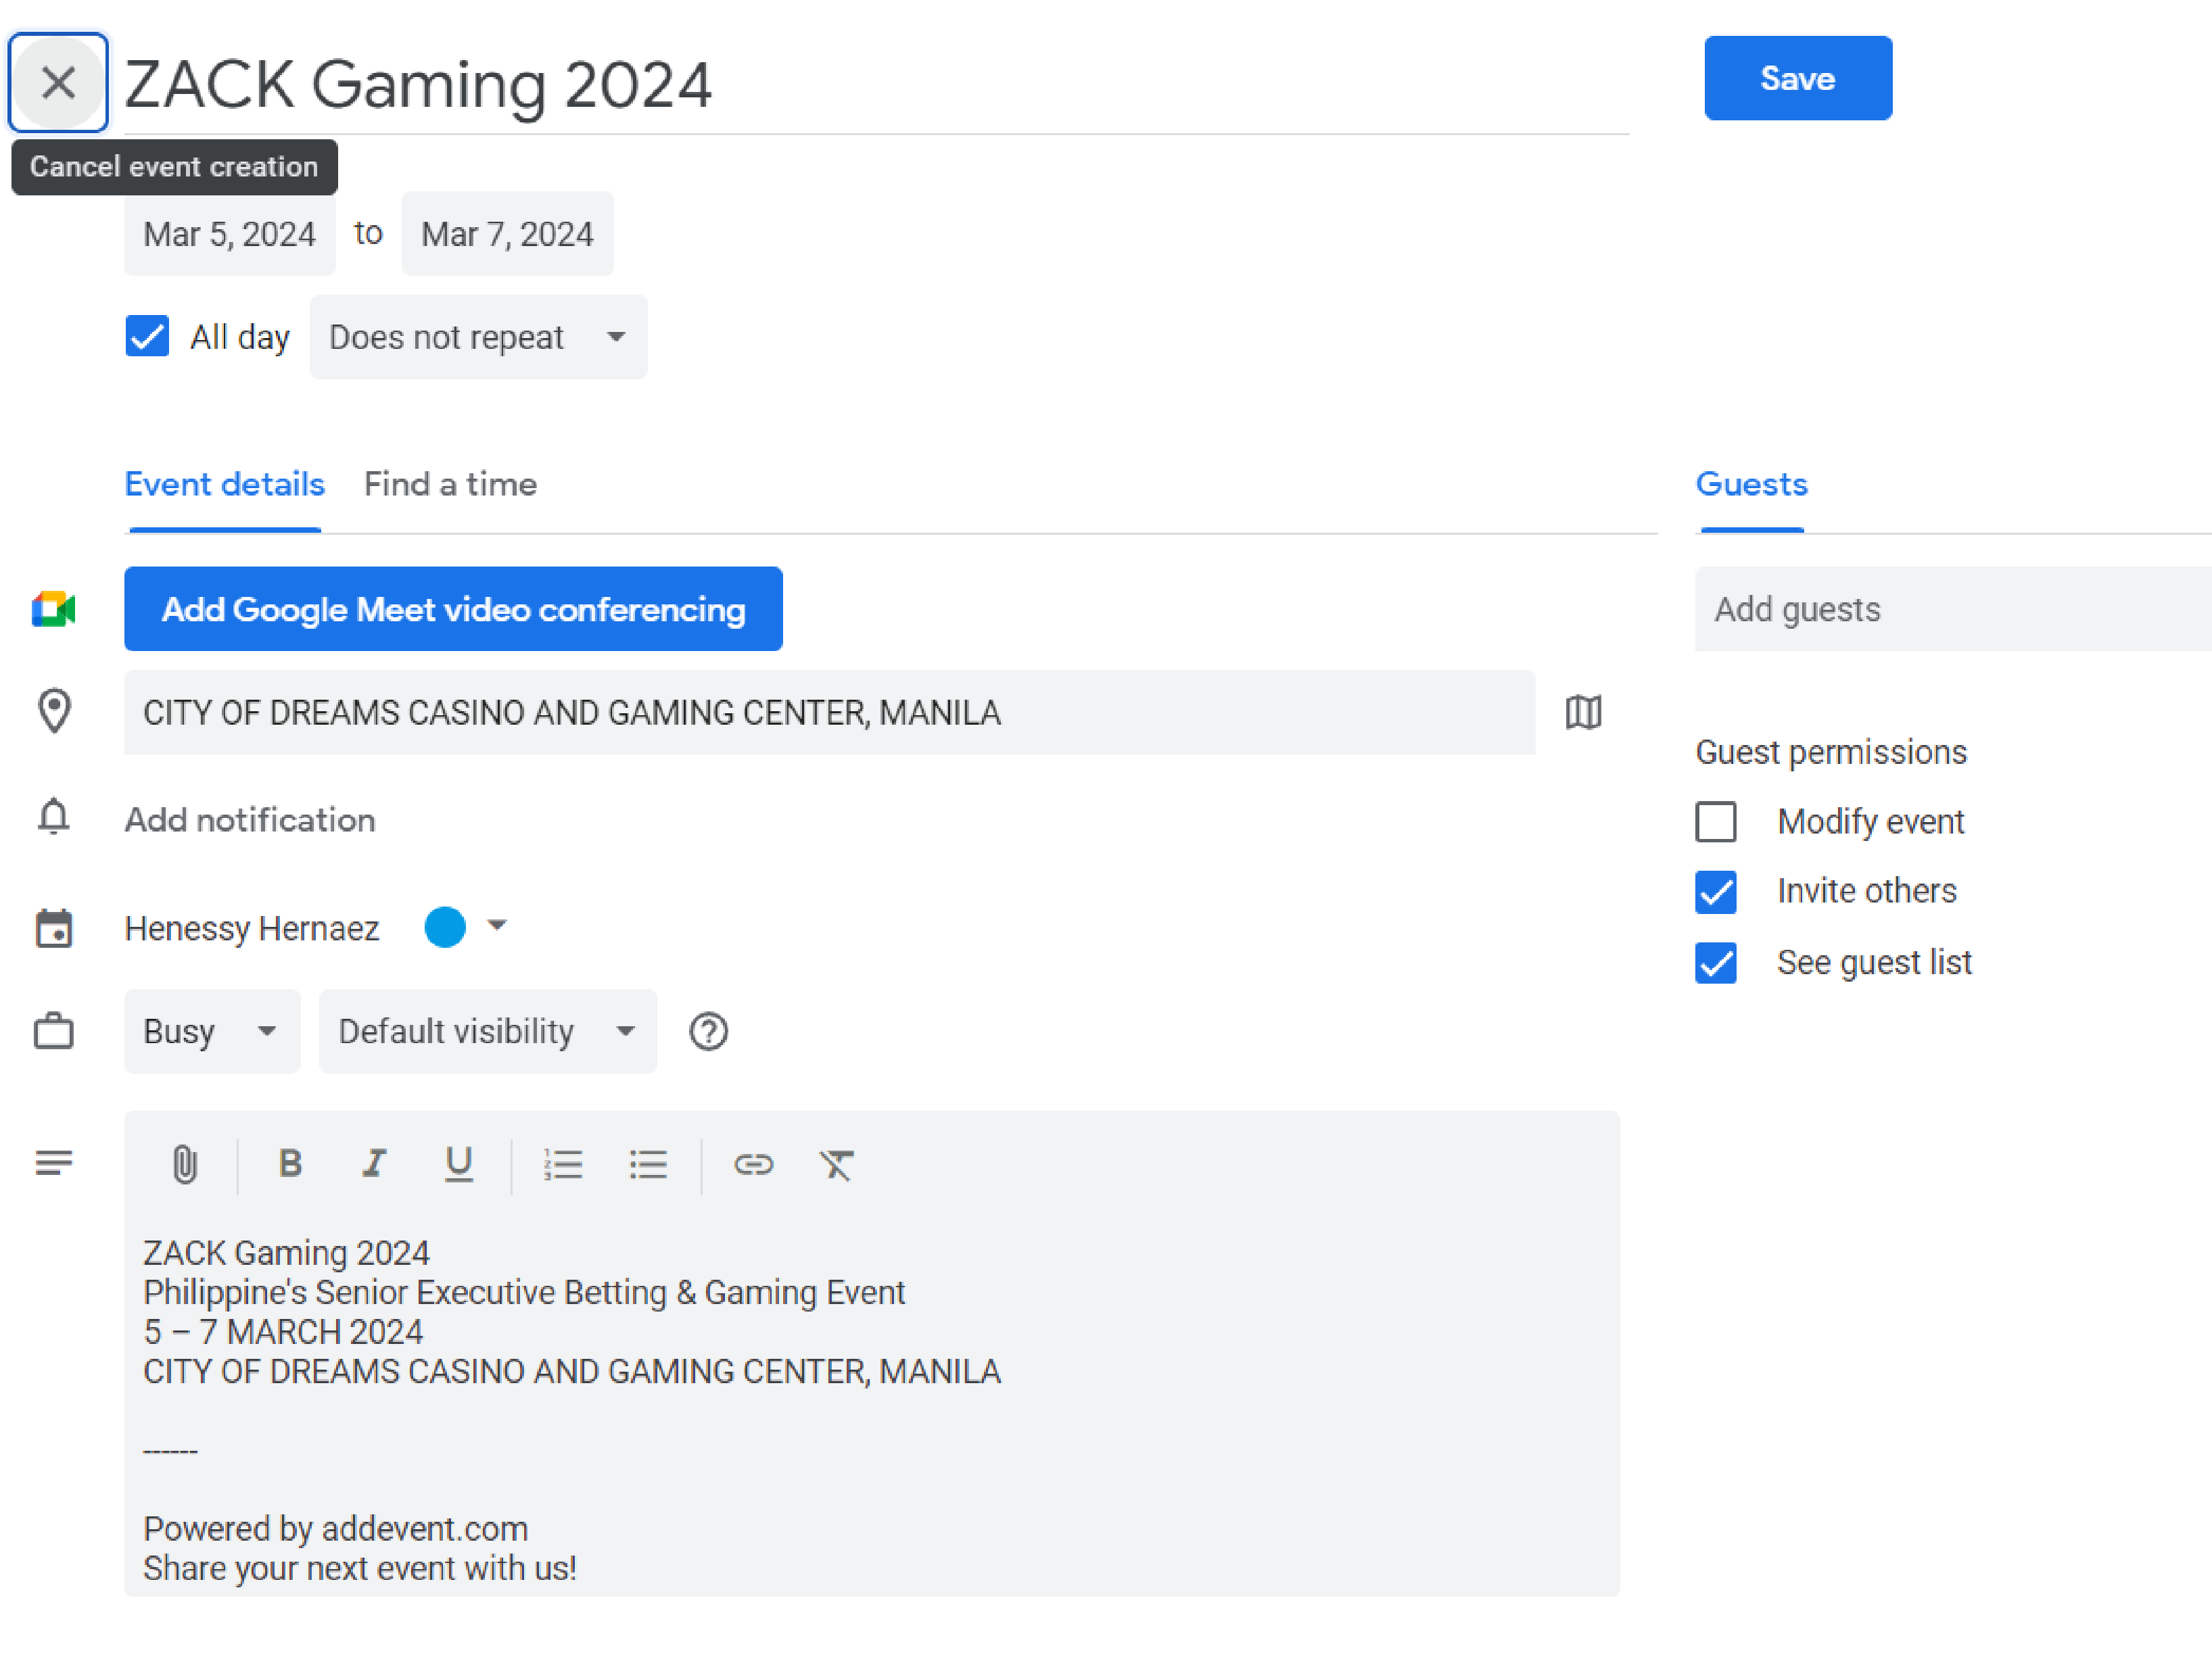

**Multilingual Features:**

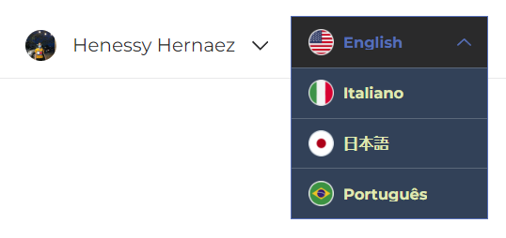

**Gallery:**

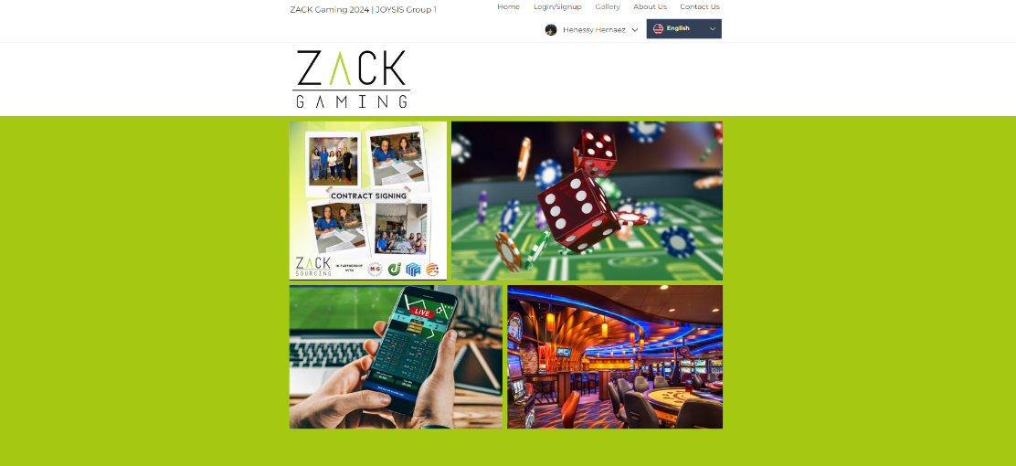





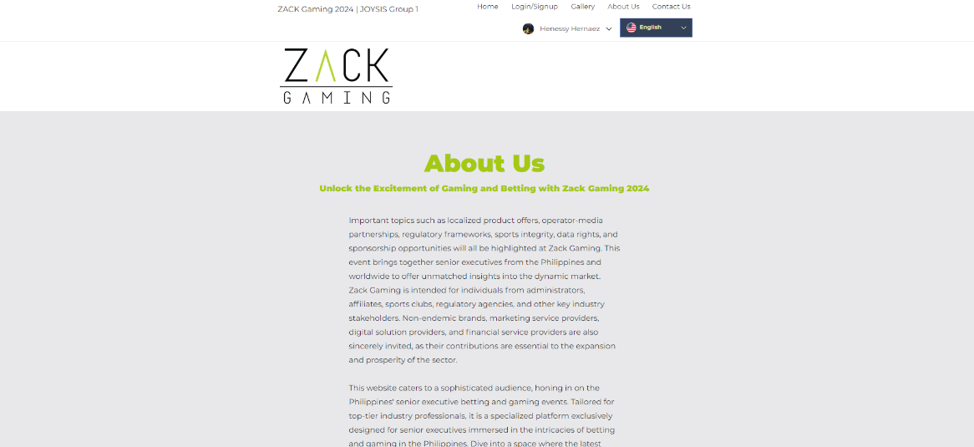**About us:**





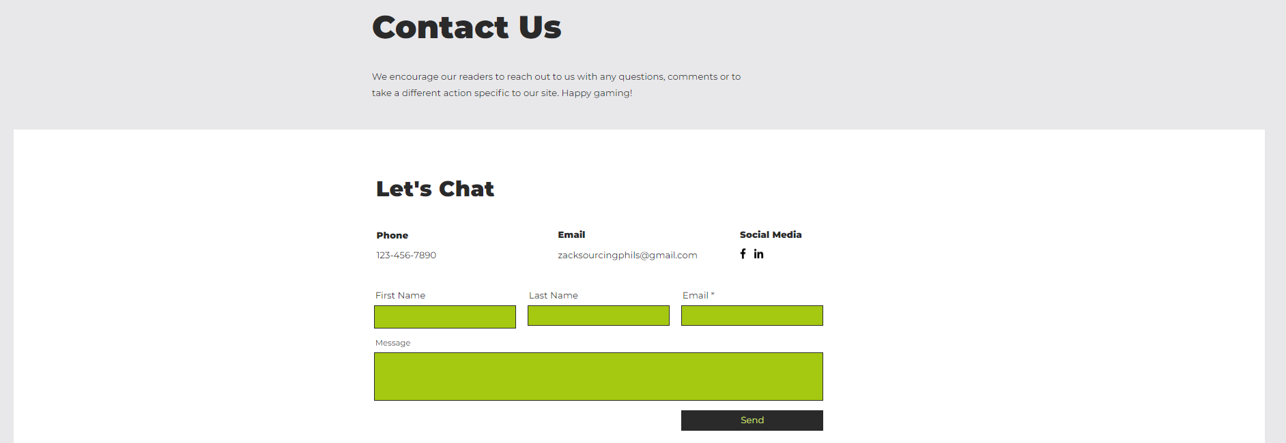**Contact Us:**

**Division of Work:**

**Wendell Centeno**

* Gallery
* Documentation
* Homepage
* Footer
* Testing

**Henessy Hernaez**

* Login
* Powerpoint Presentation
* Documentation
* About Us
* Testing

**Daff Jorda**

**Basic website:**

* Homepage
* Login
* Sign Up
* Contact Us
* Gallery
* About Us
* AddEvent
* Testing

**John Adam Ramos**

* Homepage
* Contact Us
* Log In
* Presentation
* Testing

**Clarisse Joy Sevilla**

* Homepage
* Footer
* Powerpoint Presentation
* Documentation
* Testing